Those Men Privileged to Serve
AM PM
Song Leader: Song Leader:
Bobby Penland Bobby Penland
Opening Prayer: Opening Prayer:
Butch Cannon Milton Mathers
Lord’s Supper: Reading:
Dwight Collins Scotty Arwood
Jim Blackburn Preacher:
Ronnie Harrison Jacob Martin
Dillon Andes Lord’s Supper:
Reading: Dwight Collins
Ted Williams Jim Blackburn
Preacher:
Jacob Martin
Announcements: Announcements:
Jarred Irick Jarred Irick
Closing Prayer: Closing Prayer:
Gary Cable Michael Heaton

Audio Staff: Audio Staff:
Mason Ford Mason Ford
Seth Heaton Seth Heaton

May Birthdays: May Anniversaries:
Alicia Harrison-4th
Stevie Pierce-4th
Becky Pierce-7th
Scotty Arwood-10th
Carolyn Cannon-11th
Whitney Heaton-23rd

Lets Pray for our Nation

Greeting to our visitors, we are honored that you have chosen to spend this time with us at the Centerview Church of Christ. If you have any questions or concerns, please bring them to our attention. We welcome the opportunity to study with you.
The Centerview Seeker
Published by Centerview Church of Christ May 3, 2026
“But seek ye first the kingdom of God and His righteousness…” Matthew 6:33

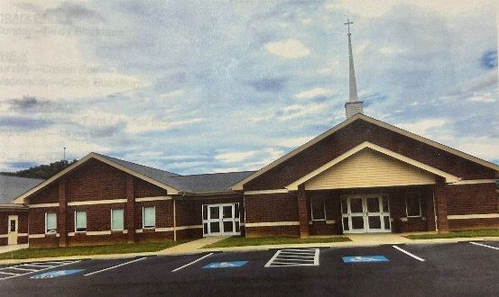
The Centerview Church Of Christ
441 Hatcher Lane
Elizabethton, TN. 37643
Minister: Jacob Martin-(540)-520-1492
Elders: Dwight Collins Dean Ray TonyHoss David Irick
Deacons: Michael Heaton-(423)-297-3232 (cell) Jarred Irick-(423)-707-8143
Centerview Church of Christ Web Address: https://viewchurch.center
Centerview Phone # (423) 518-1919 email: centerviewcoc441@gmail.com
Schedule of Services:
Sunday Wednesday:
Bible Study: 10:00 A.M. Bible Study: 7:00 P.M.
Worship: 11:00 A.M.
6:00 P.M.
Gospel Plan of Salvation:
Hear the Word: Acts 15:7
Believe the Word: Hebrews 11:6
Repent of Sins: Acts 17:30
Confess Jesus as God’s Son: Romans 10:10
Be Baptized for Remission of Sins: Acts 2:38
Be Faithful unto Death: Revelations: 2:10

The Sermon Illustration

The preacher was talking about patience and said, “Some of you need to slow down and listen for God’s voice.”
From the back, little Tommy whispered loudly, “I can’t hear Him over you!”
The preacher paused… and said, “Point taken.”

