AM
Song Leader:
James Turner
Opening Prayer:
Jarred Irick
Lord’s Supper:
Stanley Green
Jarred Irick
Tony Hoss
Dwight Collins
Reading:
Scotty Arwood
Preacher:
Jacob Martin
Announcements:
Gary Underdown
Closing Prayer:
Michael Heaton
Audio Staff:
Mason Ford
Seth Heaton
September Birthdays:
Alora Irick: 2nd
Stanley Green: 11th
Dean Ray: 12th
Mason Ford: 14th
Aylitta Collins: 15th
Dolly Irick: 17th
Jarred Irick: 19th
Libby Williams: 28th

441 Hatcher Lane Elizabethton TN, 37643
https://viewchurch.center
Greetings, we are honored that you have chosen to spend your time with us at the Centerview Church of Christ. If you have any questions, please bring them to our attention. We welcome the opportunity to study with you.
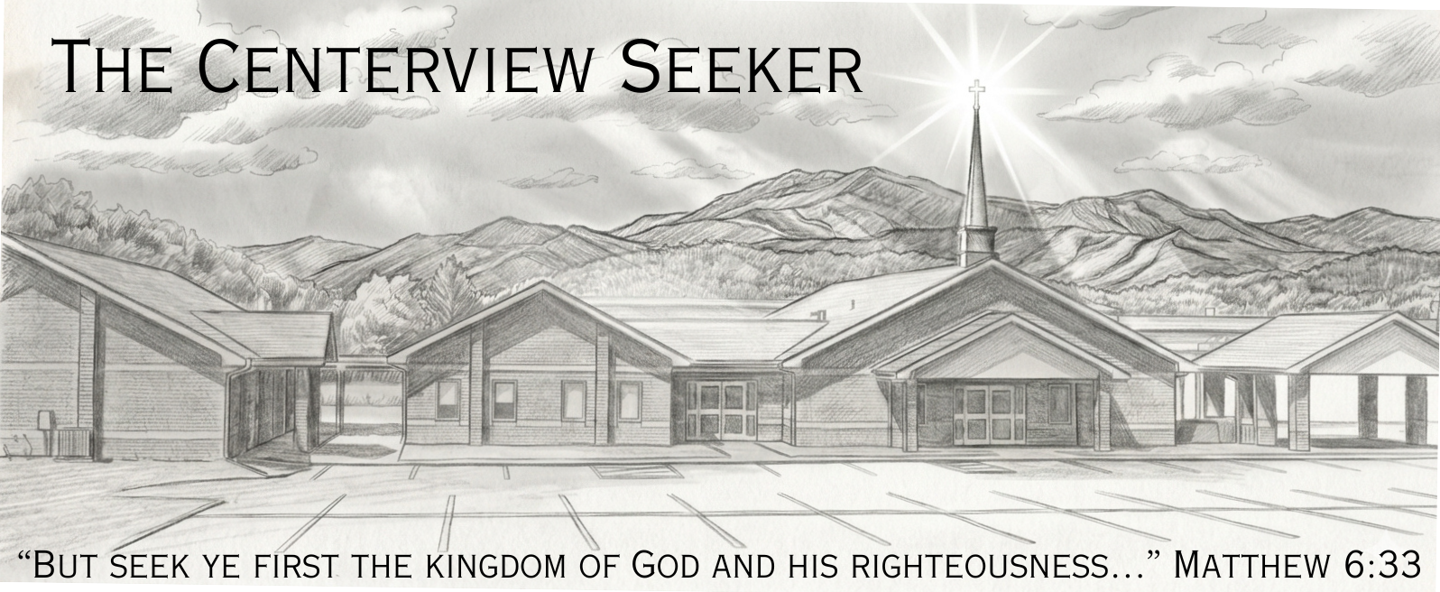
Schedule of Services:
Sunday: | Wednesday:
Bible Study: 10:00AM | Bible Study: 7:00PM
Worship: 11:00AM & 6:00PM
Gospel Plan of Salvation:
Hear the Word: |  | Acts15:7
Believe the Word: |  | Hebrews 11:6
Repent of Sins: |  | Acts: 17:30
Confess Jesus as God’s Son: |  | Romans 10:10
Be Baptized for the Remission of Sins: |  | Acts: 2:38
Be Faithful unto Death: |  | Revelations: 2:10

Minister: Jacob Martin (540) 520-1492
Elders: Dwight Collins - Dean Ray - Tony Hoss - David Irick
Deacons: Michael Heaton - Jarred Irick
Phone: (423) 518-1919 Email: centerviewcoc411@gmail.com
PM
Song Leader:
James Turner
Opening Prayer:
Jim Blackburn
Lord’s Supper:
Stanley Green
Dwight Collins
Reading:
Michael Heaton
Preacher:
Jacob Martin
Announcements:
Gary Underdown
Closing Prayer:
Tony Hoss
Audio Staff:
Mason Ford
Seth Heaton
September Anniversaries:
Scotty & Ashley Arwood: 7th
Ronnie & Kathy Harrison: 28th

