AM
Song Leader:
Bobby Penland
Opening Prayer:
Butch Cannon
Lord’s Supper:
Gary Cable
Dean Ray
Mike Blevins
Brian Irick
Reading:
Jarred Irick
Preacher:
Jacob Martin
Announcements:
David Irick
Closing Prayer:
Ted williams
Audio Staff:
Mason Ford
Seth Heaton
October Birthdays:
Mike Blevins: October 10th
James Turner: October 18th
Jamie Morrison: October 18th
Blakely Bowman: October 21st
Reed Arwood: October 28th
Rick Harris: October 31st

441 Hatcher Lane Elizabethton TN, 37643
https://viewchurch.center
Greetings, we are honored that you have chosen to spend your time with us at the Centerview Church of Christ. If you have any questions, please bring them to our attention. We welcome the opportunity to study with you.
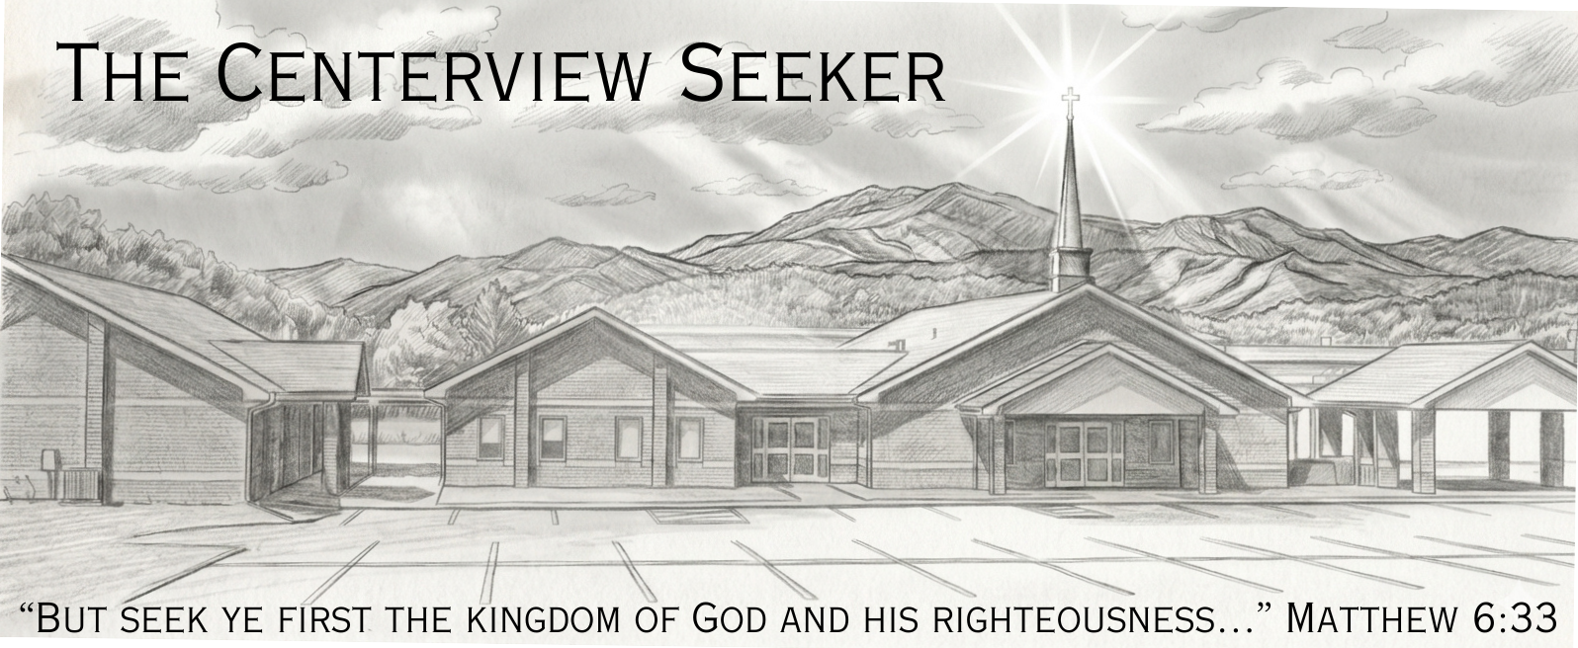
Schedule of Services:
Sunday: | Wednesday:
Bible Study: 10:00AM | Bible Study: 7:00PM
Worship: 11:00AM & 6:00PM
Gospel Plan of Salvation:
Hear the Word: |  | Acts15:7
Believe the Word: |  | Hebrews 11:6
Repent of Sins: |  | Acts: 17:30
Confess Jesus as God’s Son: |  | Romans 10:10
Be Baptized for the Remission of Sins: |  | Acts: 2:38
Be Faithful unto Death: |  | Revelations: 2:10

Minister: Jacob Martin (540) 520-1492
Elders: Dwight Collins - Dean Ray - Tony Hoss - David Irick
Deacons: Michael Heaton - Jarred Irick
Phone: (423) 518-1919 Email: centerviewcoc411@gmail.com
PM
Song Leader:
Bobby Penland
Opening Prayer:
Milton Mathers
Lord’s Supper:
Gary Cable
Dean Ray
Reading:
Ronnie Harrison
Preacher:
Jacob Martin
Announcements:
David Irick
Closing Prayer:
Mike Blevins
Audio Staff:
Mason Ford
Seth Heaton
October Anniversaries:
Jim & Cindy Blackburn: 4th
James & Brandi Turner: 15th
Michael & Donna Heaton: 17th
Rick & Shanna Harris: 24th
John & Michelle Collins: 26th

